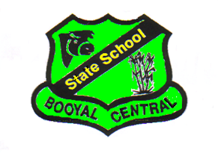

BOOYAL CENTRAL STATE SCHOOL

Homework Policy

***STATEMENT OF PURPOSE:***

At Booyal State School we are a community working together to be the best that we can be.

***We aim*** to instil a desire to achieve academically, foster life skills and social awareness, promote problem solving and creativity, and develop self-esteem and an acceptance of others.

***We strive*** to create a culture, which promotes sound values, supports the individual, embraces change, encourages positive relationships, and develops responsible environmental practices.

***ASSOCIATED MATERIAL:***

• Education (General Provisions) Act 2006

• Education (General Provisions) Regulation 2006

***STATEMENT OF POLICY:***

Homework provides students with opportunities to consolidate their classroom learning, pattern behaviour for lifelong learning beyond the classroom and involve family members in their learning.

Homework that enhances student learning:

* Is purposeful and relevant to students needs
* Is appropriate to the phase of learning (early, middle and senior)
* Is appropriate to the capability of the student
* Develops the student's independence as a learner
* Is varied, challenging and clearly related to class work
* Allows for student commitment to recreational, employment, family and cultural activities.

***RESPONSIBILITIES:***

1. Students enrolled at Booyal Central State School are responsible for the completion of homework/assignments as set by teachers in our school.
2. Homework/assignments set by teachers require students to access other expertise, resources and manage their time and social commitments in a productive manner.

1. Completion of homework commitments enables parents/caregivers to gain an understanding of current class work, and for students to consolidate their classroom learning.
2. All students and parents/caregivers are given clear directions as to the requirements of completion of homework/assignments.

5. Teachers will regularly correct/mark homework/assignments upon their completion.